Name: Per.
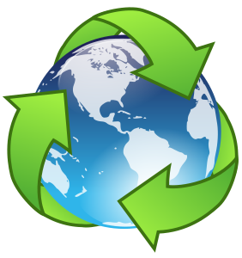
Biogeochemical Cycles
Interactive WebQuest Student Handout

Prior Knowledge: In this lesson you will discover how the components of life, carbon, water, nitrogen, and phosphorus, cycle through living and non-living things in the biogeochemical cycles. Before beginning, use the Learning Scale below to rate your knowledge of the biogeochemical cycles. Place a check in the before box. You will re-rate yourself in the after box after the lesson.
Rating Before Lesson | Learning Scale | Rating After Lesson
 | 4 I can teach others about how carbon, water, nitrogen, and phosphorus cycle between living and non-living things in the four major biogeochemical cycles.
 | 3 I can explain how carbon, water, nitrogen, and phosphorus cycle between living and non-living things in the four major biogeochemical cycles.
 | 2 I can identify the movement of carbon, water, nitrogen, and phosphorus in the four major biogeochemical cycles.
 | 1 With help, I can identify the movement of carbon, water, nitrogen, and phosphorus in the four major biogeochemical cycles.
 | 0 I do not understand the movement of carbon, water, nitrogen, and phosphorus in the four major biogeochemical cycles.

Before The Lesson - Prior Knowledge

- If “bio” means “life”, “geo” means “Earth”, and “chemical” means “chemicals”, what do you think the term “Bio-geo-chemical Cycle” means?

- Complete the “K” and “W” Sections of the K-W-L. Complete the “L” section when prompted in this lesson.
Biogeochemical Cycles
K  What  I Know | W  Questions I Have | L  What I Learned  During This Lesson

Task 1: Introduction To the Biogeochemical Cycles

Click on the following link to watch the “Biogeochemical Cycling” video by Bozeman Science. As you watch, answer the following questions.
http://tinyurl.com/q682z4o

1. What elements cycle between living and non-living organisms?

2. What is a mnemonic device to help you to remember the elements that life needs to survive?

3. Complete the table below about why each element in the biogeochemical cycle is important to life.
Element | Why Is It Important To Life?
C

H

N
O
P

S

4. True or False: Nutrients are recycled again and again in the biogeochemical cycles. True / False

5. Complete the table below about how each element is stored and cycled between living and non-living things.
 | Water | Carbon | Nitrogen | Phosphorus
Where is it stored?
How does it get into animals?

How does it get into plants?

How does it get recycled again?

Task 2: The Carbon Cycle

A. Click on the link below to watch the “Carbon Cycle” video by Study Jams. After you watch the video,
write 1-2 things you learned about this cycle in the “L-Column” of the KWL on page one of this handout.
http://tinyurl.com/hj4pfof

B. Click on the link below to access the “Carbon Cycle” interactive activity from PBS Learning Media™ website. As you complete the activity, answer the following fill-in-the-blank or short answer questions. Press “Launch” to begin the activity.
http://tinyurl.com/olbp8ks

6. Every living thing on Earth is made of , including .

7. Today, there is the same amount of carbon that was on Earth years ago, and the same amount that will be on Earth years from now.

8. The word “Biogeochemical Cycle” is a fancy term for the ways that elements like carbon and water move around, interacting with Earth’s and parts.

9. Everyday, what two ways can you take in carbon?

10. How does your body release carbon?

11. Why is CO₂, carbon dioxide, important to plants?

12. What do plants give off, or release, as a result of photosynthesis? Why is this important?

13. What do bacteria, fungi, and other decomposers do with the carbon after plants die?

14. What occurs when there is more carbon than decomposers can use?

15. The Earth’s crust and mantle are called Carbon sinks that hold carbon. What other thing on Earth holds the world’s carbon?

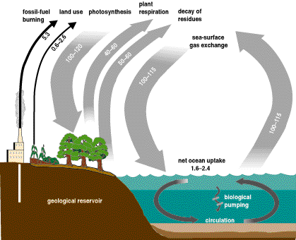
16. In your own words, explain how carbon cycles between living and non-living things.

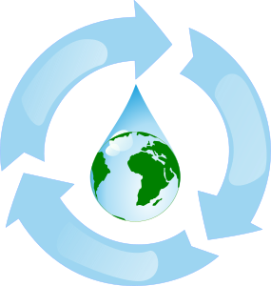
Task 3: The Water Cycle
A. Use the link below to watch the “Water Cycle” video by Study Jams. After you watch the video,
write 1-2 things you learned about this cycle in the “L-Column” of the KWL on page one of this handout.
http://tinyurl.com/c792x89

B. Use the link below to complete the Water Cycle for Schools interactive from the USGS website. Hover over each step of the water cycle to complete the following table. http://tinyurl.com/k7gh477
Water Cycle Part | 3 Facts About This Part | Sketch Something About This Part
17. Sun
18. Atmosphere
19. Condensation
20. Precipitation
21. Sublimation
22. Infiltration
23. Runoff
24. Oceans
25. Evapotranspiration
26. Choose Your Own Step
_______________

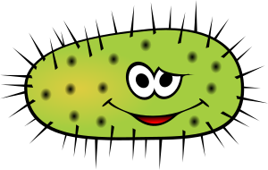
Task 4: The Nitrogen Cycle

A. Click on the link below to watch the “Nitrogen Cycle” video by Study Jams. After you watch the video, write 1-2 things you learned about this cycle in the “L-Column” of the KWL on page one of this handout.
http://tinyurl.com/93wyyn4

B. Click on the link below to access the “Nitrogen Cycle” interactive activity from PBS Learning Media™ website. As you complete the activity complete the following fill-in-the-blank questions. Press “Launch” to begin the activity.
http://tinyurl.com/lxlbug3

27. Introduction Nitrogen is an element essential to life it is found in , ,
, and in molecules important to . Most living things cannot absorb in its gaseous form, and rely on a process called to obtain nitrogen.

**Press Play and watch the movement of Nitrogen in the Nitrogen Cycle. Then hover on the italic terms that define the steps in the Nitrogen cycle in order to fill in the blanks for the following questions.

28. Nitrogen in the Atmosphere and fill in the blanks. Nitrogen gas makes up about of the air in our atmosphere., which in turn holds up of the nitrogen on .

29. Nitrogen Fixation: Fixation occurs when convert nitrogen gas into compounds that living organisms can take up.

30. Ammonification: Ammonification occurs when bacteria or convert nitrogen gas or nitrogen compounds into ions.

31. Nitrification: Nitrification is a two-step process: soil first convert ions into ions, then convert nitrite ions into ions.

32. Denitrification: Denitrification occurs when soil convert ions into nitrogen .

33. Assimilation: Assimilation occurs when living take up nitrogen.
Task 5: The Phosphorus Cycle

A. Click on the link below to watch the “Phosphorus Cycle In 65 Seconds” video by Bonniebojangles. After you watch the video, write 1-2 things you learned about this cycle in the “L-Column” of the KWL on page one of this handout.
http://tinyurl.com/lz7gwv2

B. Click on the link below to access the “Phosphorus Cycle” interactive by Discover Biology. Click the “Narrated” icon to move throughout the interactive.
http://tinyurl.com/yb8aesp

34. What two cell components contain phosphorus?

35. How do animals obtain phosphorus?

36. What type of organism breaks down dead materials and releases phosphate back into the soil?

37. What is the main reservoir of phosphorus on earth?
Congrats!
You’ve Completed the Lesson! Be Sure to Re-Rate yourself on the learning scale on page one of this handout!

